***Dt : 30/8/2022***

***Execution flow of above program:***

***ClassFiles:***

***Customer.class***

***DemoCon3.class(MainClass)***

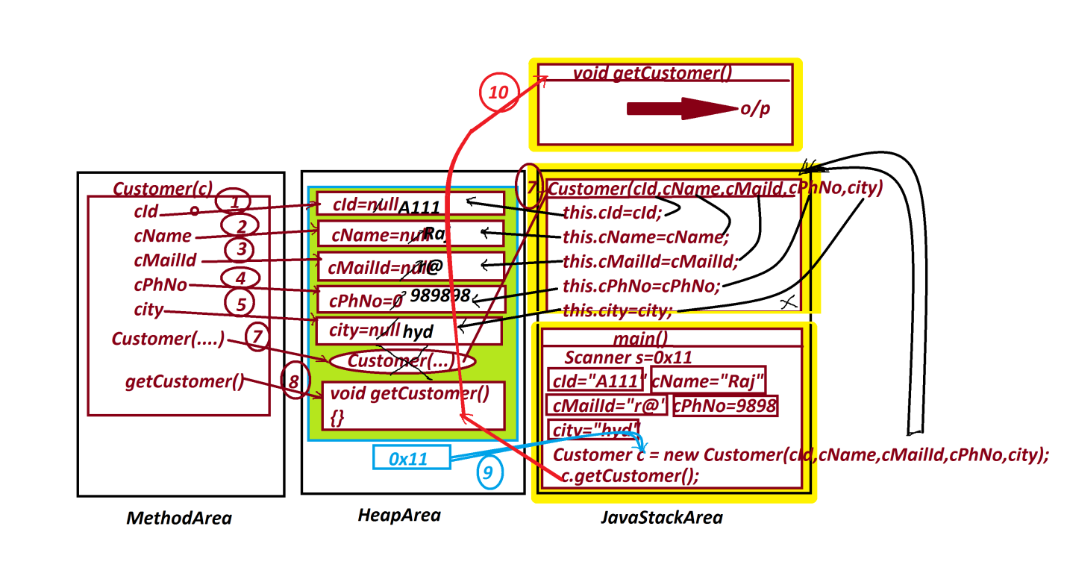

***============================================***

***faq:***

***define "this" keyword?***

***=>"this" is a pre-defined Non-Primitive datatype variable and***

***which is holding the reference of Current running object.***

***=>"this" variable is used to access the members from the object.***

***faq:***

***In wt situation "this" keyword is used?***

***=>when we load data from local variables to Instance variables***

***and if they are having same names then we must use "this" keyword.***

***==========================================================***

***\*imp***

***Loading data to Object:***

***=>we use the following three ways to load the data to Object:***

***Process-1 : Using Constructor***

***Process-2 : Using reference variable(Using Object name)***

***Process-3 : Using Setter methods***

***Process-1 : Using Constructor***

***=>we use constructor to initialize instance variables while***

***object creation process.***

***Ex:***

***DemoCon3.java***

***Process-2 : Using reference variable(Using Object name)***

***=>we can load the data to objects using Object reference***

***variable or Object name.***

***Ex:***

***DemoMethods10.java***

***DemoMethods11.java***

***Process-3 : Using Setter methods***

***=>we can also load the data to objects using 'Setter methods'***

***Ex : DemoCon4.java***

***import java.util.Scanner;***

***class ProductDetails //SubClass***

***{***

***String pId,cId,pName;***

***float pPrice;***

***int pQty;***

***void setProductDetails(String pId,String cId,String pName,***

***float pPrice,int pQty)***

***{***

***this.pId=pId;***

***this.cId=cId;***

***this.pName=pName;***

***this.pPrice=pPrice;***

***this.pQty=pQty;***

***}***

***void getProductDetails()***

***{***

***System.out.println("=====ProductDetails====");***

***System.out.println("ProdId:"+pId);***

***System.out.println("CustId:"+cId);***

***System.out.println("ProdName:"+pName);***

***System.out.println("ProdPrice:"+pPrice);***

***System.out.println("ProdQty:"+pQty);***

***}***

***}***

***class DemoCon4 //MainClass***

***{***

***public static void main(String[] args)***

***{***

***Scanner s = new Scanner(System.in);***

***System.out.println("Enter ProdId:");***

***String pId = s.nextLine();***

***System.out.println("Enter CustId:");***

***String cId = s.nextLine();***

***System.out.println("Enter ProdName:");***

***String pName = s.nextLine();***

***System.out.println("Enter ProdPrice:");***

***float pPrice = s.nextFloat();***

***System.out.println("Enter ProdQty:");***

***int pQty = s.nextInt();***

***ProductDetails pd = new ProductDetails();***

***pd.setProductDetails(pId,cId,pName,pPrice,pQty);***

***pd.getProductDetails();***

***}***

***}***

***o/p:***

***Enter ProdId:***

***A121***

***Enter CustId:***

***C234***

***Enter ProdName:***

***Mouse***

***Enter ProdPrice:***

***1200***

***Enter ProdQty:***

***12***

***=====ProductDetails====***

***ProdId:A121***

***CustId:C234***

***ProdName:Mouse***

***ProdPrice:1200.0***

***ProdQty:12***

***===================================================***